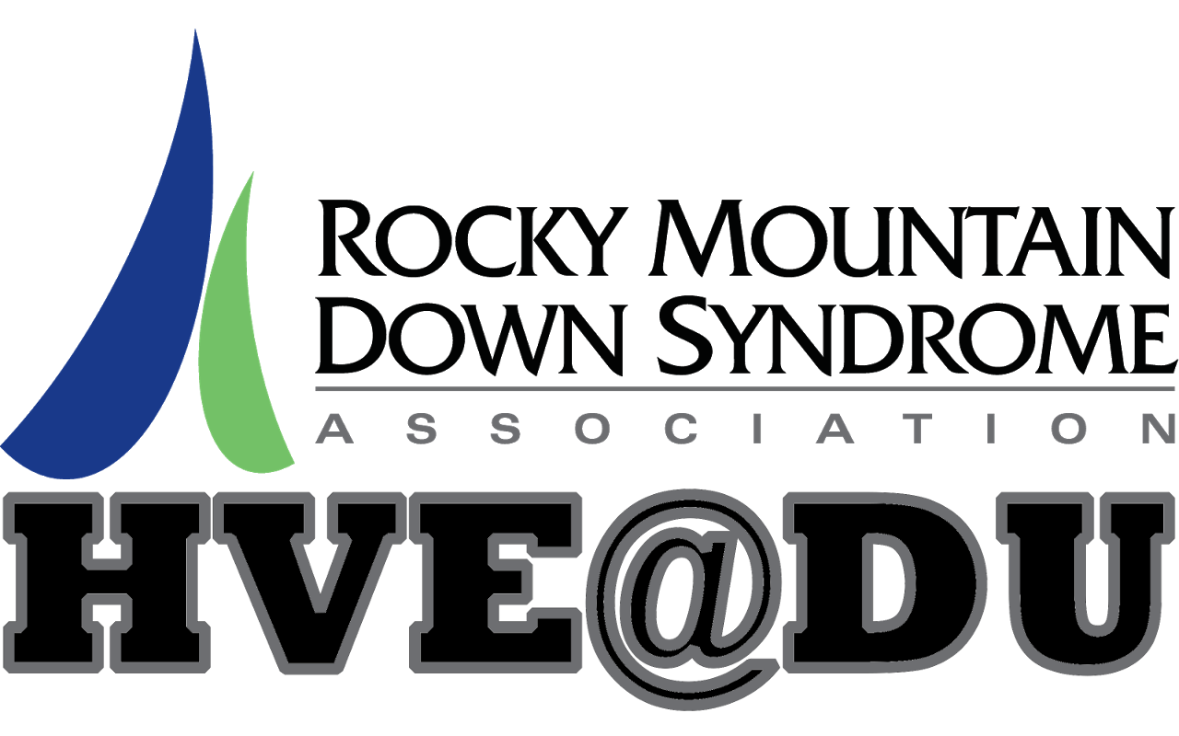
Skills and Habits for Lifelong Wellness

Quarter 1, 2019

January 30 and 31 – Welcome Class- Overview of quarter topics and brainstorm of student interests and learning goals; social skills activity; board games.
February 6 and 7– Healthy Snack Potluck Planning Session- Students will work in small groups to plan their end of quarter healthy snack potluck, and utilize their iPads to research and save healthy snack recipes and create and save shopping lists.
February 13 and 14 – Community Health and Fitness Resources- We will research and share various community resources for staying fit and healthy; including a tour of the Ritchie Center at DU.
February 20 and 21- Healthy Habits in the Community- Group bus trip to the library to practice community safety skills and explore the resources available at the library.
February 27 and 28 – Dance Fitness- Dancing for fitness and fun, with the DU Dance team. We will walk to the Ritchie Center for this event.
March 6 and 7– Health for adults with Down Syndrome- We will review and discuss the specific ways having Down Syndrome effects student physical and mental health and wellness. With guest speaker.
March 13 and 14 – Healthy Snack Potluck (Students Only)- Students will prepare and share healthy snack recipes, and participate in dance fitness activities. We will also have a guest presentation from a former HVE student who is now attending college at CSU with IN!
March 20 and 21– Fitness for adults with Down Syndrome- We will review and discuss the specific ways having Down Syndrome effects student fitness and exercise, participate in a workout led by Sarah Mann, PT/DPT, and created healthy living vision boards.

Special Events:
-2nd annual Peter Naffah DU Hockey Outing, Friday Feb 22, 2019
5:00pm dinner, 7:00pm game

