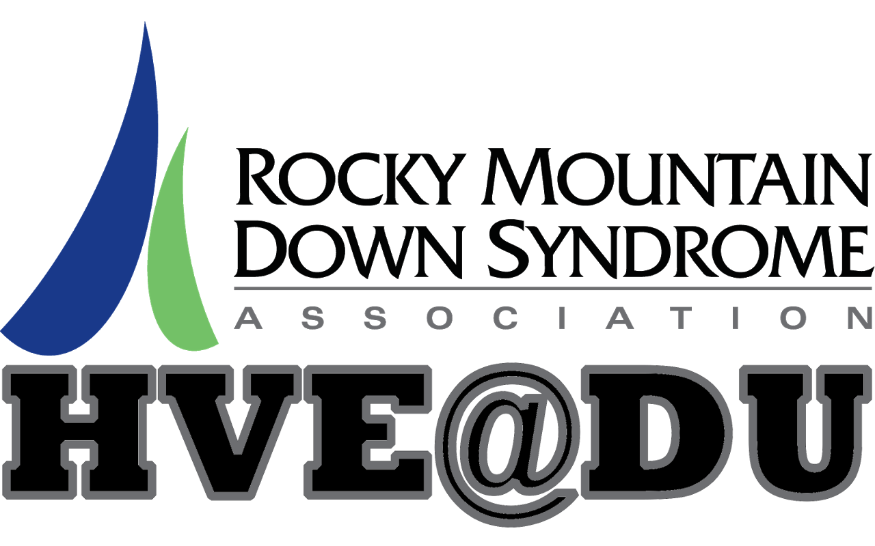
Nutrition and Cooking for Lifelong Wellness
& HVE Cooking Show

Quarter 3, 2018

August 22 and 23 – Welcome Class. Overview of quarter topics and brainstorm of student interests and learning goals.
August 29 and 30 – Nutrition Overview- (DU Guest Speaker) Our guest speaker will share with us the basics of lifelong wellness nutrition, including snack and meal planning, organizing a healthy plate, portion control, and the link between nutrition, hydration, energy and wellness.
September 5 and 6 – Nutrition and recipes on the iPad- In preparation for their cooking show project, students will use their iPads to research and save one or two healthy recipes, and then create an ingredients list from their saved recipes.
September 12 and 13– Cooking Show Planning Session- Students will work in small groups to brainstorm and plan their cooking show scripts, including researching recipes, preparing a shopping list, and writing a basic script.
September 19 and 20 –- iPad Video Workshop- Guest presenter Tim Gilbert will be here to walk the students through the video features on the iPad.
September 26 and 27– Cooking Show Taping Session- with DU Cooking Club and Guest Judges.
October 3 and 4 – Cooking show Editing Session- Students will work with their groups and DU Film student volunteers to edit and finalize their cooking show videos.
October 10 and 11 – Cooking Show Screening and Celebration- Friends and families are invited to join us for an end of quarter celebration and screening of HVE’s final cooking show videos

